COMP7022
Programming for Artificial Intelligence with Python
Class 9&10
_____________________________________________
In this class we will practice clustering with Python using Scikit-learn. To get started, create a Jupyter workbook and call it Class 5. The solutions to the following questions are based on Scikit-learn concepts that we have seen in the lectures. If you find that your solution is not based on what was discussed then you might want to reconsider your approach.
All questions form part of the assessment. Please show your work to the supervisor for credit.
We will be using http://raptor.kent.ac.uk/~lb514/Data/ClusterDs1.csv
and http://raptor.kent.ac.uk/~lb514/Data/ClusterDs1.csv
Exercises:
- Load the dataset ClusterDs1.csv into a DataFrame and make a scatter plot using the plt.scatter() function.
- From the scatter plot of the previous exercise, you got a good idea of how many cluster the data represents. Now create a K-Means model to find the clusters, and fit it to the data points from the previous exercise.
- Using the model trained in the previous step, use the predict() method to get a list of cluster labels. Assign the result to a variable named labels.
- Using the labels from the previous exercise, update the plot to show points in different colour depending on what cluster they belong.
- Load the dataset ClusterDs2.csv from the Moodle page into a separate DataFrame. Using the model trained from the previous step, use the predict() method to get a list of cluster labels for the data. Assign the result to a variable names predicted_labels.
- For each data point in the DataFrame of the previous step, calculate the Euclidean distance to each of the centroids of the cluster model. You can obtain the coordinates of the centroids using the.cluster_centers_ attribute of the K-Means model. The Euclidean distance is given by:
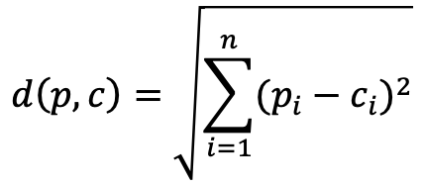
where
- $p_{i}$ is the $i$-th dimension of the point $p$
- $c_{i}$ is the value of the $i$-th dimension for centroid $c$
- $n$ is the number of dimensions
- Using the distance values calculated in the previous step, add a new column to the DataFrame from Step 5 to store the value representing the index of the centroid that the point is closer to – e.g., 0 if the data point is closer to centroid 0, 1 if the data point is closer to centroid 1, and so forth.
- Compare the predicted cluster labels (Step 5) with the cluster labels calculated in Step 7 – they should be the same.

